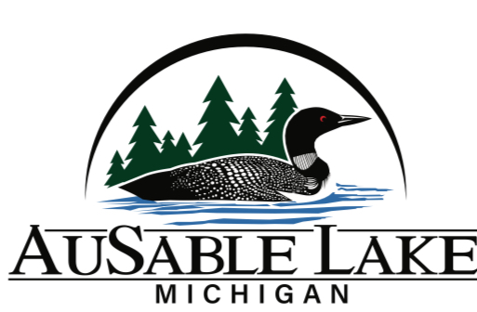

Social Calendar

**2025**

* **Faull Inn Social Night** Thursday, May 22
* **Kids Fishing Derby** Saturday, June 7
* **Corn Hole Tournament** Thursday, June 19
* **AuSable Lake QUAD** Friday, July 4
* **Boat Parade** Saturday, July 5 (Theme: Favorite Animal)
* **Euchre Tournament** Tuesday, July 22
* **Boat-in Movie** Pirates of the Caribbean Sat., Aug 9
* **5th Annual Party @ Point** Thursday, August 28
* **Light Up the Lake Unity Night** Sun, August 31
* **Faull Out of Summer –** Friday, October 3

Look for details on the AuSable Lake Facebook page or ALPOA web page.

Questions:

E-mail Julie Oakley at jaoakley5@gmail.com